Research Model

Introduction
The goal of this model is detecting a new signal on intraday data of SPY (S&P500 ETF). The found signal at time t has predictive power on the next positive movement in price from t to t+1.
The signal is applied from Extreme Value Theory (please refer to attachment for more details).
Formally, the theory states that: given a distribution with cumulative density function (cdf) F. We sample multiple of iid random variables: R₁, R₂, … R_{n} and consider maximum series as: M_{i} = max(R₁, R₂, …, R_{i}). Now, let’s define new random variables: X_{n} = (M_{n} – b_{n})/a_{n}, then, for large enough n, X_{n} will follow a known distribution (type I - Gumbel, type II - Frechet, or type III - Weibull) depending on the heavy or light or bounded tail in the original cdf F. Additionally, a_{n} and b_{n} can also be found by the original cdf F.
An informal way of understanding this theory is that if we draw multiple iid random variable R_{i} after n trials, we know the distribution of expected maximum value (from R₁ to R_{n}).
I apply this theory in finding signal by:
- Split the intraday time series to multiple blocks. (Assume the returns behave similarly within each block)
- For each block, I observe the maximum return M_{t} = max(R₁, …R_{t}) up to time t.
- If this M_{t} is significantly smaller than the expected maximum (after t trials), under the assumption that everything is normal, there is a chance that in the next period, the returns R_{t+1} must be large so that M_{t+1} can converse back to the expected maximum distribution.

Data

Raw data
- I collected minute data level of SPY from Interactive Broker (IBKR) from 2011 up to end of 2025-07-10 and store in a parquet file in “data” folder.
- There are 6 columns in raw data: trading date, open, high, low, close, and volume.
- The index of dataframe is in UTC timezone.

Data Processing
- Resample data to 5 minutes frequency bar.
- Add target variables: ret_{t} = close_{t} / close_{t-1} – 1
- Add extra time related columns:
  - Open_time: the first time of that trading date
  - Close_time: the last traded time of the trading date
  - Start_time: 30 minutes after market open
  - End_time: 60 minutes before market close
- Mask the intraday data (i.e. from start_time to end_time)
The motivation to focus the data from start_time to end_time is that the theory assumes the random variable should behave similarly from a distribution cdf F. However, for US equity, it is commonly known that the opening session and closing session return distribution behave quite differently. The volume is significantly larger than the intraday session volume and the trends also may be different from the intraday session. In this research, I only focus on intraday session data and from that perspective, I define the returns during that session is the benchmark series.

Methodology
This research procedure can be split into these steps:
- Fit extreme value theory (EVT)
- Form an empirical returns distribution with cdf, pdf, ppf estimator. Denote the functions as:
  - F(x) = CDF(x) = Pr(X < x)
  - f(x) = PDF(x) = F’(x)
  - g(y) = PPF(y) = F⁻¹(y) = x s.t. F(x) = y
- Under Gumbel domain, the EVT states that:
  - $b_{n}=g(1-\frac{1}{n})$
  - $a_{n}=\frac{1}{n×f(b_{n})}$
  - $F_{n}\left(x\right)=Pr\left(M_{n}<x\right)= Pr\left(\frac{M_{n}-b_{n}}{a_{n}}<\frac{x-b_{n}}{a_{n}}\right)=\operatorname{Pr}\left(X_{n}<\frac{x-b_{n}}{a_{n}}\right)=e^{{-e}^{-\frac{x-b_{n}}{a_{n}}}}$
where n is the number of trials and X_{n} approximate to Gumbel distribution.
- Run through history and mask out all shortlisted periods that the cdf is significantly small (<0.01).
- For loop through every day, use the return R_{t} data in the previous 4 weeks to form an empirical distribution for daily use.
- For one day, split the trading hour to hourly blocks.
- For every hour:
  - Form a series ranging from 1 to 12 (1 hours=12 times 5 minutes) and fit in EVT to have get CDF function
  - Create a cumulative max series (M₁, M₂, …M₁₂)
  - Fit the cumulative max series to CDF function to get the probability that the expected max less than this actual M₁ -> M₁₂. The probability is low meaning that the return series behave unusual low.
  - Mask these unusual periods (except the first 3 periods since the EVT is only valid when n is large enough). Record the next 5 minutes bar return after the shortlisted periods for analysis.
- Conduct hypothesis testing on the shortlisted periods.
In this part, I want to answer 2 questions. The first question is whether the mean returns of shortlisted periods is significantly larger than 0. The second question is whether the mean returns of shortlisted periods is significantly larger than the benchmark returns series. For this reason, I created 2 hypotheses tests:
  - Using 1 sample t-test to test mean of shortlisted periods is 0:
Null hypothesis: $\overline{R_{t}}=0$ vs Alternative hypothesis: $\overline{R_{t}}>0$
  - Using 2 samples t-test (with different variance) to test mean of shortlisted periods is the same as mean of benchmark returns:
Null hypothesis: $\overline{R_{t}}=\overline{B_{t}}$ vs Alternative hypothesis: $\overline{R_{t}}>\overline{B_{t}}$
- Run backtest using shortlisted periods and visualize results.
Using basic trading rule is long/short 1 unit of SPY. I computed the metrics for the return series and show backtest performance.

Result and conclusion
Both tests show significant p values which indicates that we can reject null hypothesis and accept the alternative hypothesis:
TtestResult(statistic=4.4593080724226875, pvalue=4.126340811611443e-06, df=29601)
TtestResult(statistic=3.1819567908465936, pvalue=0.000731878034371891, df=48611.23201132423)
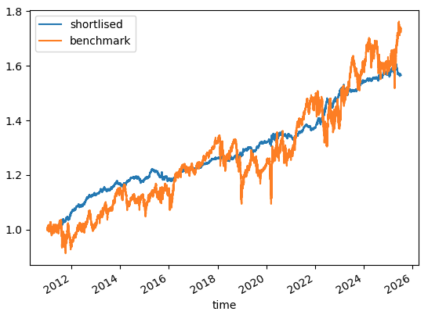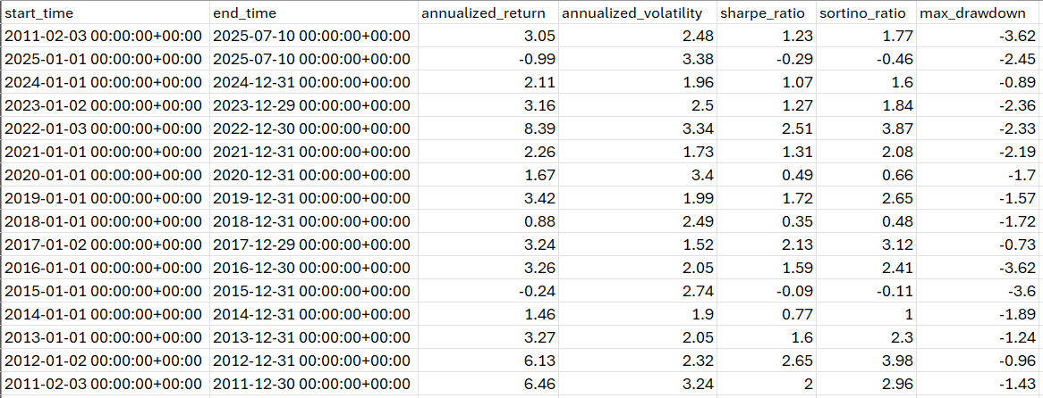
The returns and volatility are quite small which indicates that it should be improved by using a better allocation or leverage methods. However, from the equity curve plot, this signal strategy has much better volatility than the benchmark volatility.

